**Creating a persuasive presentation:**

Here's a step-by-step guide to making a persuasive presentation:

**1. Understand Your Audience**

* **Research**: Know who they are, their interests, values, and what motivates them.
* **Tailor Your Message**: Adapt your content to resonate with the audience's beliefs and needs.

**2. Clear and Compelling Message**

* **Define Your Goal**: What do you want the audience to think, feel, or do after your presentation?
* **Key Message**: Develop a clear, concise, and compelling central message that supports your goal.

**3. Structured Content**

* **Introduction**: Start with a hook to grab attention. Introduce your main idea and explain why it matters.
* **Body**: Organise your main points logically. Use the rule of three: present three strong arguments or points to support your message.
* **Evidence**: Use statistics, quotes, examples, and stories to back up your points.
* **Conclusion**: Summarize your main points and restate your message. End with a strong call to action.

**4. Engaging Visuals**

* **Slide Design**: Keep slides clean and visually appealing. Use high-quality images, infographics, and minimal text.
* **Consistency**: Maintain a consistent theme and style throughout your presentation.

**5. Emotional Appeal**

* **Storytelling**: Use stories to connect with your audience emotionally.
* **Passion**: Show your enthusiasm and passion for the topic. It’s contagious and can influence your audience.

**6. Credibility and Trust**

* **Credibility**: Establish your expertise and authority on the topic early on.
* **Trustworthiness**: Be honest and transparent. Use reliable sources and cite them.

**7. Effective Delivery**

* **Practice**: Rehearse multiple times to become familiar with your material and timing.
* **Body Language**: Use confident body language, eye contact, and appropriate gestures.
* **Voice**: Vary your tone, pace, and volume to maintain interest and emphasize key points.

**8. Engage Your Audience**

* **Questions**: Ask rhetorical questions or invite audience participation to keep them engaged.
* **Interactive Elements**: Use polls, Q&A sessions, or activities to involve your audience.

**9. Handle Objections**

* **Anticipate**: Think about potential objections or counterarguments your audience might have.
* **Address**: Prepare responses to address these objections confidently and convincingly.

**10. Follow Up**

* **Provide Materials**: Offer handouts, summaries, or additional resources.
* **Call to Action**: Clearly state what you want the audience to do next and make it easy for them to act.

By following these steps, you can create a persuasive presentation that effectively communicates your message and motivates your audience to take action.

**Topic ideas:**

* **Travel experiences:** Sharing memorable trips, favourite destinations, and cultural discoveries.
* **Personal hobbies and interests:** Discussing activities like sports, cooking, photography, or gardening.
* **Favourite books, movies, or TV shows:** Reviewing recent reads or recommending entertainment options.
* **Pet ownership:** Talking about experiences with pets, responsibilities, and the joys of animal companionship.
* **Childhood memories:** Recounting funny or heartwarming anecdotes from growing up.
* **Daily routines:** Describing typical daily activities, schedules, and habits.
* **Famous landmarks or tourist attractions:** Sharing information about iconic landmarks, historical sites, or natural wonders.
* **Family traditions:** Explaining customs, celebrations, or rituals passed down through generations.
* **Career aspirations:** Discuss future goals, dream jobs, or vocational interests.
* **Cultural celebrations:** Exploring holidays, festivals, and traditions from different cultures.
* **Favourite foods or recipes:** Sharing culinary preferences, cooking experiences, or family recipes.
* **Music preferences:** Talking about favourite genres, bands, or memorable concert experiences.
* **Personal achievements:** Reflecting on accomplishments, challenges overcome, or proud moments.
* **Learning a new skill:** Discussing experiences with learning a musical instrument, language, or craft.

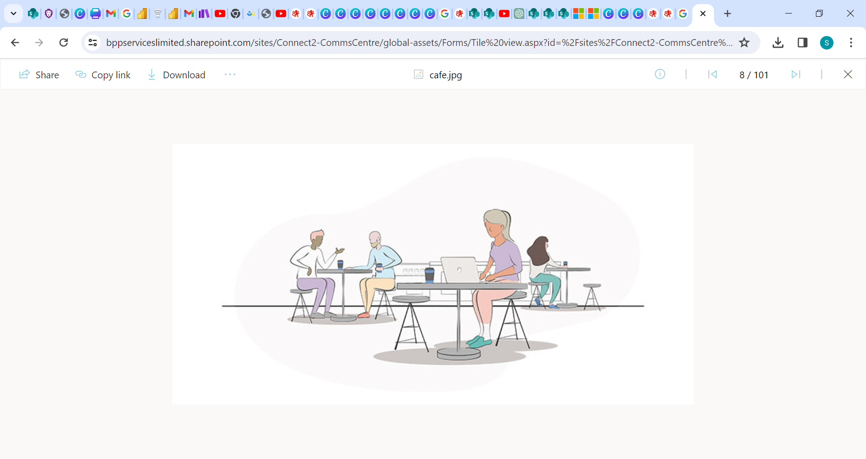

Contact- FunctionalSkills@bpp.com